ПОЛОЖЕНИЕ
Международного конкурса музыкантов
INTERNATIONAL Music Moscow
Competition
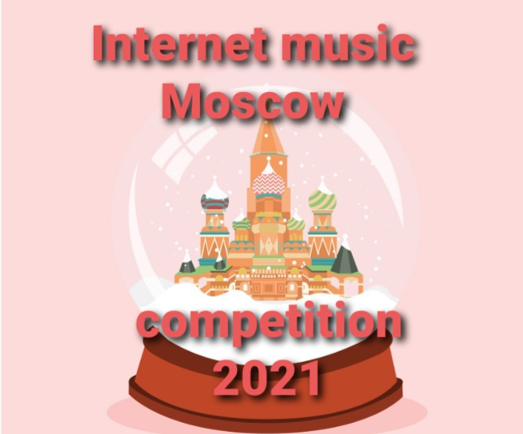
Moscow, Russia
15.12-20.12.2021

Goals and objectives of the contest
The goal and objective is that the work of a teacher with a student during one academic year will be presented at the original competition in the world, and with the help of the most powerful medium of our time – the Internet. The idea of INTERNATIONAL MUSIC Moscow is modern and attracts new technologies, gives an incentive to musicians of all ages to improve and create! Due to material and geographical reasons, not everyone can afford to participate in an International competition, and the competition gives them such a chance!
After all, there are so many talented musicians all over the world!
Founders and organizers of the contest
АНО Центр культуры и искусств « Гранд» г. Москва
Partner European Associatition of Folklore Festivals-ICH Partner of UNESCO
Арт- Центр г.Москва

Terms and conditions of the competition

The date of the contest 15.12.2021-20.12.2021
Gala concert 20. 12.2021
The contest takes place entirely via the Internet in round 1.
Absentee participation– based on video recordings, participants send two video recordings to the contest email: link to the video in You Tube, the video must be signed with the contestant's last name, age or group.(For example, Sasha Ivanov, Second group: 12 years). In the video settings on the YouTube channel, we do not put it for children!

Nominations:
1. piano
2. folk instruments (gutare, house, balalaika. bayan, accordion, gusli).
3. string and bow instruments (viola, violin, cello, counterbass, harp)
4. woodwind and brass instruments (Flute, saxopfon, horn, fagot, clarnet, oboi, percussion instrument).
5. academic and folk vocals.
6. chamber ensembles
7. orchestras
8 choir
Age categories:
Group I: 7-9 years old;
Group II: 10-12 years old;
Group III: 13-15 years old;
Group IV: 16-20 years old;
V Group: pro or teacher..

The competition is held in one round, the participant must complete the program specified in the application.
Post your video so that the whole world can hear it!
Unlike other competitions, when the huge musical energy, work and efforts of students and teachers are almost finished within a few minutes and then forgotten, this competition provides you with the only opportunity for millions of Internet users from all over the world to listen to the participant's performance an unlimited number of times. We are confident that the competition will expand, attracting more and more new talents, expanding the horizons of professional and spiritual growth.

Program requirements for instrumentalists:
Soloists – 2 works of various
types ensembles-2 works (music is allowed)
orchestras - (Wind, folk, chamber, symphonic.) 2-3 works
Choirs - 2-3 pieces.
The composition of the jury, the order of work:
The jury consists of experts in the field of culture and art: honored workers of culture, leading teachers of educational institutions, famous artists, composers, musicians. The composition of the jury changes periodically. The composition of the jury may not change significantly for reasons beyond the control of the Organizing Committee.
The contestants ' performances are evaluated according to a 100-point system.
The decision of the jury is final and cannot be changed. The results are announced 5 days after the contest. They are sent to all participants by email.
Evaluation criteria: the degree of proficiency in the instrument, the purity of intonation and musical structure, the
complexity of the repertoire and arrangement, the possession of a dynamic palette of sound, musicality,
artistry, artistic interpretation of a musical work,
creative individuality for individual performers.
Summing up, awarding:
The results and awards are held in the categories taking into account the specified age categories and provide for the award of the following places:
Participants are evaluated based on the average score of the jury members ' ratings:
* Laureate I (Gold Diploma) - awarded to the participant who has scored at least 90, oo/100 points
* Laureate II (Silver Diploma) is awarded to the participant who has scored at least 80, oo points
* Laureate III (Bronze Diploma) is awarded to the participant who has scored at least 70, oo points
* Diploma (Copper diploma) is awarded to the participant who has scored at least 60 points
The number of laureates ' diplomas is not limited.

Special prize for the best
Teacher and concertmaster of the competition.

The prize is for the youngest contestant!
The prize for artistry!
Special prize-An invitation to perform at a concert of the Moscow Conservatory in the summer season 2022
GRAN-PRI-The soloist, duo or ensemble, the first-degree winner, who scored the highest number of points in the competition category, receives the diplom Grand Music Champion of the World.
.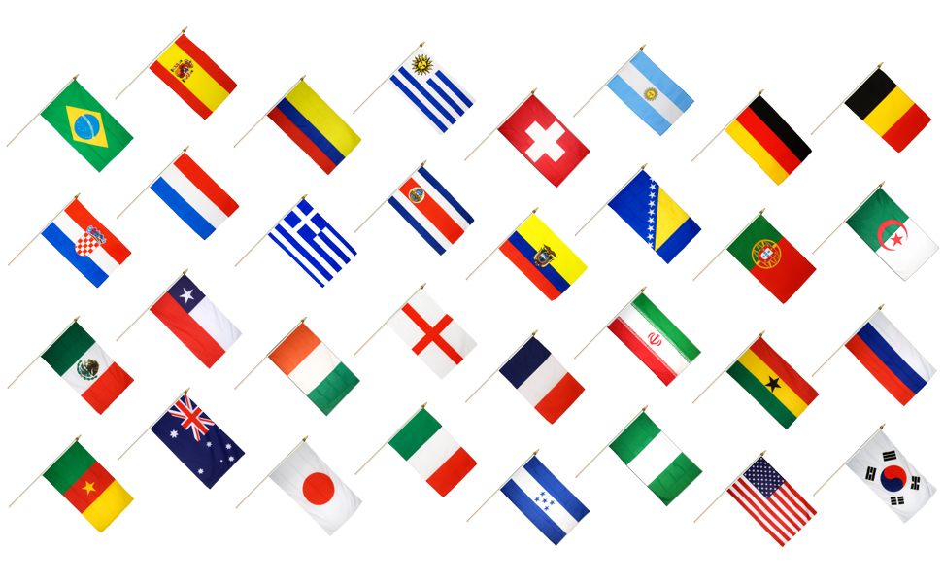
Financial conditions for absentee participation:
Financial conditions for absentee participation by video recordings –
Solo-30 euros, for CIS countries 1500 rubles
Ensembles (from 2 to 10 people) 35 euros per duet, for CIS countries 1800 rubles.from the ensemble.
Choirs, orchestras, groups (from 10 people) 40 euros per group, for the CIS countries 2500rub.
The diploma does not say that the participation is in absentia.

Composition of the Jury:
Wind instruments:
Nikolai Popov-Russia Soloist of the Bolshoi Theater Orchestra of Russia, flutist, saxophonist, arranger and composer, teacher of the Schnittke MGIM
Dmitry Tagan-Mongolia-saxophonist, winner of international competitions.

Piano:
Pablo Miro, Mexico-pianist, performer of the Ruiz miro Trio
Vagner Mery Hanover Germany-pianist, music school director.
String instruments:
Pavel Minev Bulgaria
"Modern Paganini" - is included in the world's top list of outstanding artists "Great Artists - Musical World".
Ksenia Zharko Russia-Conductor of the Moscow Operetta Theater, conductor of the Globalis Chamber Orchestra, trainee conductor at the State Academic Bolshoi Theater of Russia, Conductor of the State Concert.

Folk instruments:
Ledeniv Andriy, Russia-Honored Worker of Culture of the Russian Federation, folk instruments, Professor of the Schnittke MGIM.
Nguyen Tai, Vietnam-accordionist of the National Academy of Music of Vietnam.
Vocal creativity:
Luca Lattanzio –Itallia –Tenor composer songwriter.
Shutova Marina, Russia – Honored Artist of Russia, Prima of the Bolshoi Theater, solo opera and chamber singing of the M. M. Ippolitov –Ivanov State Music Institute

Applications and videos are accepted until 15. 12. 2021
The receipts are sent after the application is received.
Coordinates of the Organizing Committee:
E – mail: infogrand-festival@mail.ru

Tel.,whatsApp
+7916 779 0417

