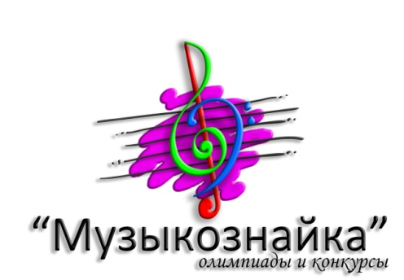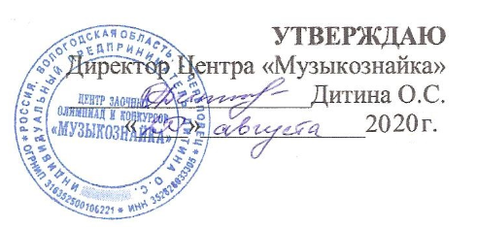

REGULATION

on holding II International competition of folk instruments’ performers
«Native chants»
January 22, 2021

1. General regulations:
Regulation on holding of II International competition of folk instruments’ performers “Native chants” (further – Regulation) sets out the order of carrying out this event, organizational and methodological support, procedure for participating and selecting winners and prize-winners of the Competition.
The Contest Organizer is represented by Supplementary Education Centre «Musicoznayka». The official language of the competition is Russian.

2. Aims and objectives:
- popularization of folk-instrumental culture;
- identification and support of young talented performers;
- preservation and enhancement of the traditions of the national musical and pedagogical school of playing on folk instruments;
- popularization of national instruments of the nations of Russia.

3. Procedure and timing of the Contest:
The competition is held remotely. Students of children's music schools and children's art schools and teachers as well are invited to participate in the competition (performers on folk instruments - bayan, accordion, balalaika, domra, guitar and national instruments). The age of participants is not limited.
The competition is held in several categories:
- "soloists";
- "ensembles" (up to 10 performers);
- "orchestras" (more than 10 performers);
- the ensemble of "teacher-student".

3.1. Age groups:
- Junior group I – up to 8 years old (inclusively)
- Junior group II – 9 – 10 years old (inclusively)
- Middle group I – 11 – 13 years old (inclusively)
- Middle group II – 14 – 16 years old (inclusively)
- Senior group – from 17 years old.

Age of the participants is determined on January 22, 2021. The age group in nomination «Teacher and student» is determined by the age of the student. Nominations «Ensembles» and «Orchestras» - no restrictions.

3.2. Programme requirements:
The competition program for all categories consists of one work – the processing of a folk song or dancing.

3.3. Video requirements:
Video files recorded in a static frame are allowed to participate in the competition (MP4, MPEG, AVI, WMV formats). The hands, instrument, and face of the performer must be clearly visible during the performance. The amateur format is allowed if all other conditions of the competition are observed. Video files (or links to them) are sent to the email: musicoznayka@yandex.ru.Video size must not exceed 300 МB.
The Organizing Committee reserves the right to post the contest works on the website of "Muzicoznayka", and the right to use the contest videos for advertising purposes.

4. Terms of the Contest:
Registration of the Contest participants finishes at 23:59 (according to Moscow time) on January 22, 2021.
For registration, you have to send an application for participation (Attachment 1), a video file of the performance (or a link to it), and a scanned copy of the payment receipt to the email: musicoznayka@yandex.ru. You will receive a notification email that the materials have been acquired. If such a letter is not received in 3 working days, please resend the materials.
Please, monitor the correct completion of the application, because according to its data award documents will be drawn up.

5. Financial conditions:
The registration fee for participation in the Contest is 7 euros. (requisites - Attachment 2).

In case of refusal to participate in the contest, the registration fee is not refunded.

6. Jury:
Jury is formed of high-qualified specialists after assembling of all applications.
Jury is entitled to:
- to award not all the places;
- to share one place between several participants.
The jury has the last word
The jury has been working since January 23 up to February 7, 2021г.
7. Competitor evaluation criteria:
- Performance skills and technical perfection of performing;
- Musicality and artistry;
- Expressiveness of performing;
- Originality of the choice of repertoire;
- Stage outlook.

8. Awards:
- participants are awarded with diplomas of the International competition "Native chants" with the title "Laureate" (I-II-III places), "Diploma-winner" (IV place), and "Participant". Special diplomas may be awarded at the discretion of the jury;
- all the teachers, who have prepared the participants, and concertmasters receive Letters of Thanks from the International Competition "Native chants";
- participants of the Contest receive award materials (diplomas and letters of thanks) in electronic form.

Registration and distribution of award materials are carried out since February 8, 2021 till March 7, 2021 in electronic form.

The results of the Contest are posted on the website www.musicoznayka.ru on February 8, 2021.

8. Contacts:
Registered office: Cherepovets, Vologda region, Russia.
E-mail: musicoznayka@yandex.ru
Website: www.musicoznayka.ru
Phone number: 89814322215 Olga Sergeevna (from 10a.m. to 6p.m. - according to Moscow time zone).

Attachment 1

An application for participation in the International contest «Native chants»:

Name of institution (full name), address
Full name
(or the name of orchestra/ensemble)
Age group
Instrument
Nomination
Performance programme
Teacher’s full name

Full name of the Head (for ensembles, orchestras)
Concert master’s full name
E-mail (for prize papers)
We are informed and agree with the Regulations on holding II International Competition of Performers on Folk Instruments "Native Chants" and the conditions of participation. We guarantee the payment of the registration fee of €7 .
Submission of application and participation in the competition implies the unconditional agreement with all provisions of this law. It also means the consent of the participant, or his legal representative for processing, storing, and using personal information in the technical documentation of the contest on paper and electronic media.
Attention! Reception of applications is until January 22, 2021 (inclusively).
APPLICATIONS ARE ACCEPTED ONLY IN THE FORM OF A WORD DOCUMENT!
APPLICATIONS WILL NOT BE ACCEPTED IN SCANNED FORM!
Please, monitor the correct completion of the application, because according to its data award documents will be drawn up.

Attachment 2
Beneficiary PE DITINA OLGA SERGEEVNA
Beneficiary account 40802978800000015114
Beneficiary Transit Account 40802978020000015114
Beneficiary's bank Tinkoff Bank
Beneficiary SWIFT TICSRUMMXXX
Beneficiary's bank address 1st Volokolamsky pr., 10, bld. 1, Moscow, Russia
Intermediary J.P.MORGAN AG FRANKFURT AM MAIN, DE
Intermediary SWIFT CHASDEFXXXX
Intermediary's account 6231608701

